


MINISTRY OF EDUCATION AND TRAINING
UNIVERSITY OF ECONOMICS AND FINANCE

PROJECT REPORT

<Desktop Application Development>

TOPIC
<Apartment Business Management>

Major: Information Technology
Minor: Software engineering

Ho Chi Minh City, 2025

Supervisor: Hoàng Văn Hiếu
Student ID 1: 225054137 Student’s name 1: Nguyễn Văn Việt
Student ID 2: 225054039 Student’s name 2: Lê Phi Anh
Student ID 3: 225053771 Student’s name 3: Nguyễn Tuấn Hưng

Class: B05E

Student’s Name | Student’s ID | Progress | Tasks
Nguyễn Văn Việt | 225054137 | 45/100% | Create Database  Login/Register Function.  Manage Contracts Function.  Manage service unit prices Function.
Lê Phi Anh | 225054039 | 45/100% | Create Database  Manage Rooms Function.  Manage Invoices Function.  Manage service unit prices Function.
Nguyễn Tuấn Hưng | 225053771 | 10/100% | Manage Tenant information Function.  Change Password Function.

Ho Chi Minh City, 2025

TABLE OF CONTENTS
Chapter I: Introduction
- Abstracts
- Tool & Function
- Sketch
Chapter II: Database
1.Data table
- Login/Register table
- Manage Rooms table
- Manage Tenant information table
- Manage Contracts table
- Manage Invoices table
- Electricity and Water management table
- Manage Invoices Details table
2.Entity Relationship Diagram
Chapter III: List of Images
- Login/Register
- Manage Rooms
- Manage Tenant information.
- Manage Contracts
- Manage Invoices
- Electricity and water management.
- Invoices Details
- Statistical
- Search function
- Change Password
- Export Excel file
- Suggestion Box
Chapter IV: Upcoming features And Conclusion
- Login by Google and Facebook
- Send invoices to tenants through email
- Conclusion

CHAPTER 1: INTRODUCTION
1. ABSTRACTS
As we know, society is increasingly developing, the Service industry is a group of industries with rapid growth in recent year. Along with that, many hotels and motels are open to serve several types of services such as tourism, resorts, ... according to human needs. Therefore, the management work in motels or hotels is becoming more and more difficult. That promotes the need for suitable management software for motels and hotels to solve the above problem.
That is why we want to create apartment business management software, with simple but complete functions as possible; aiming to improve and consolidate the knowledge learned, applying it into practice.

2.TOOL & FUNCTIONS
Tools used: Window form, C#, SQL Server, Figma
The reason why we choose these tools is:
+ Window form:
- Provides an intuitive drag-and-drop interface, making application interface design quick and easy, especially for beginners.

- C# is a modern language, easy to learn and has clear syntax, suitable for students or beginners.

+ SQL Server: As a powerful database management system, it has a friendly interface with tools like SQL Server Management Studio (SSMS), making it easy to manage data.
+ Both Visual Studio and SQL Server are developed by Microsoft, so they work very well together.
+ There are plenty of documentation, video tutorials, and support forums for both C# and SQL Server. This makes it easy for students to find solutions when they run into problems.
+ Visual Studio 2022 has a free Community edition, which is sufficient for project use.
+ SQL Server also has a free Developer edition, which provides full features for learning and development purposes.
+ Figma:
- Figma works directly in the browser, does not require powerful computer configuration or complicated installation.

- There is a free version with many features, enough for personal or study projects.

- Multiple people can work on the same project at the same time, which is useful for group assignments or team projects.

- Easily create interactive prototypes to simulate how your app or website works.

- Target audience: For Landlords and Who Want to Start Up in This Business Field
- Functions:
+ Login/Register
This function allows users to create an account and log in to the program to perform other functions. When registering an account, the email must end with gmail.com.
+ Manage Rooms (add/delete/edit room information)
This function allows users to enter and add, delete, and edit information related to the room such as:
- Room code
- Building
- Floor
- Room number
- Rent price
- Description
This function can be searched by existing conditions

+ Manage Tenant information
This function allows users to enter and add, delete, and edit information related to the tenant such as:
- Tenant code
- Room code
- Full name
- Phone number
- ID card/citizen identification card
- Date of birth
- Gender
- Hometown
This function can be searched by existing conditions except Date of birth

+ Manage Contracts (add/delete/edit contract information)
This function allows users to enter and add, delete, and edit information related to the contract such as:
- Contract Code
- Room Code
- Tenant Code
- Name
- Deposit
- Status
- Signed Date
- Expiry Date
This function can be searched by existing conditions except Signed Date and Expiry Date

+ Manage Invoices (add/delete/edit/issue invoices)
This function allows users to enter and add, delete, and edit information related to the Invoices such as:
- Room Code
- Invoices Code
- Date time
- Promotion
- Cleaning
- Internet
- Another service
- Status
- Note
This function can be searched by Room Code, Status and Note

+ Electricity and Water management
This function allows users to enter and add, delete, and edit information related to Electricity and Water index such as:
- Electricity and Water code
- Room code
- Date time
- Old electricity index
- New electricity index
- Electricity consumption
- Electricity bill
- Old water index
- New water index
- Water consumption
- Water bill
- Electricity price
- Water price
This function can be searched by Room code

+ Invoices Details
This function is used to generate a detailed invoice for that room by month.
- Numeric order
- Invoices details code
- Service name
- Old index
- New index
- Quantity
- Unit price
- Total amount

+ Statistical
This function is used to calculate statistics by electricity bill, water bill, room bill, some other services and total revenue.
+ Search function
The search function will be available in other functions to help users find information accurately and quickly.
+ Change Password
This function helps users change their password.
+ Export excel file
This function helps users export information into file excel
+ Suggestion box
When we click on the suggestion box, it will lead to a google form page for us to respond.
+ Log out
This function allows users to log out the program.

3. Sketch
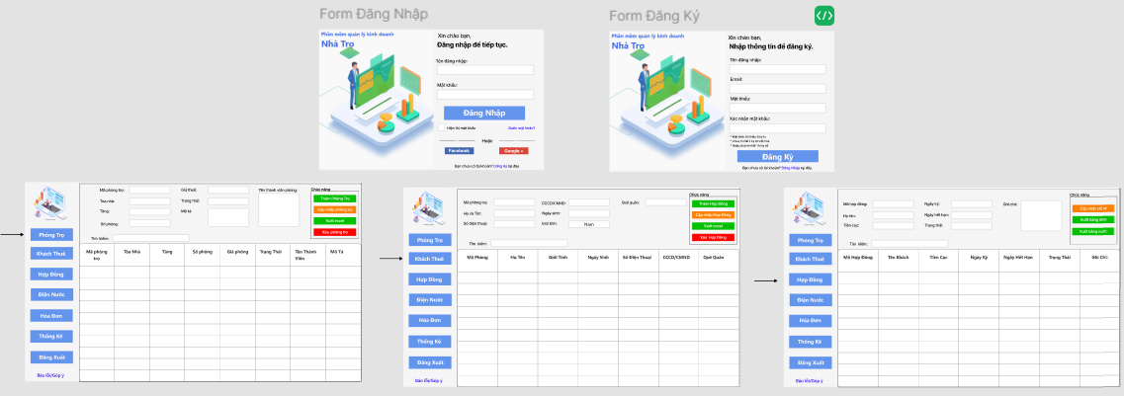
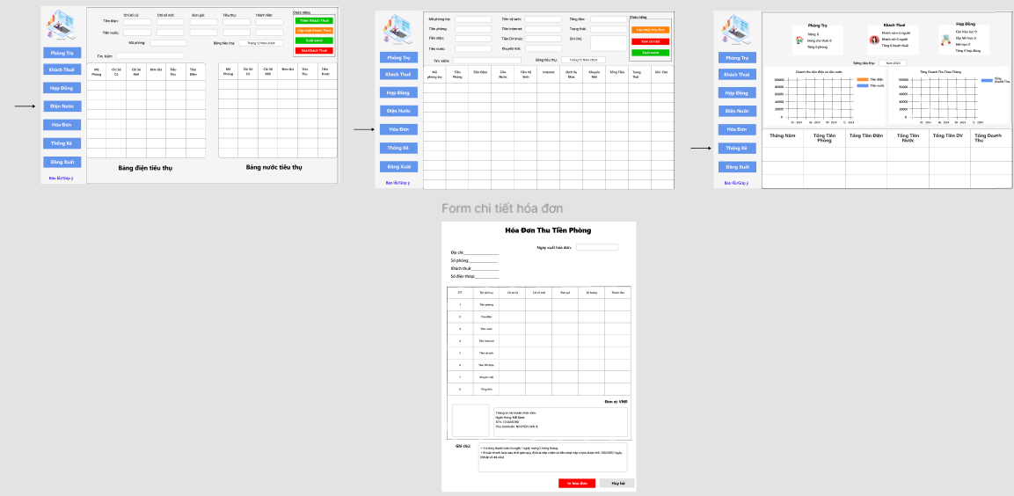
- This is the sketch we made with Figma, in this sketch we sketched the login and registration form first, then we sketched the main functions of the application which are room management, tenants, contracts, invoices, electricity and water, statistics and finally the bill details.

- Here is the link to our group's sketch:

https://www.figma.com/design/FkrZRwRTKdyTD2uex4Xhqa/Ph%C3%A1c-th%E1%BA%A3o-app?node-id=0-1&m=dev&t=QF3sTyfOXVbDtjLh-1

CHAPTER II: DATABASE
1.Data Table
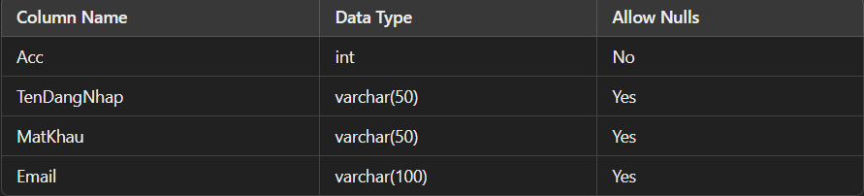
- Login/Register table

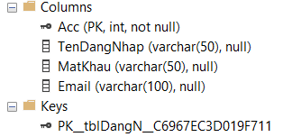
- Description: Stores user login information.

- Acc: Primary Key identifies account

- Login Name, Password, Email: Login and contact information

- Manage Rooms table

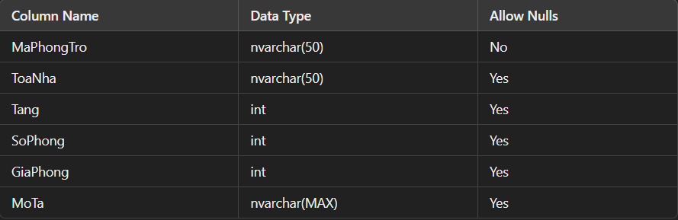

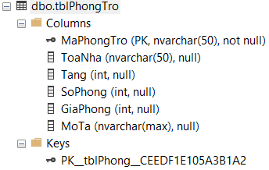

- Description: Save information about rooms

- MaPhongTro: Primary Key identifies each room.

- Other information such as: building, floor, room number, room price, description.

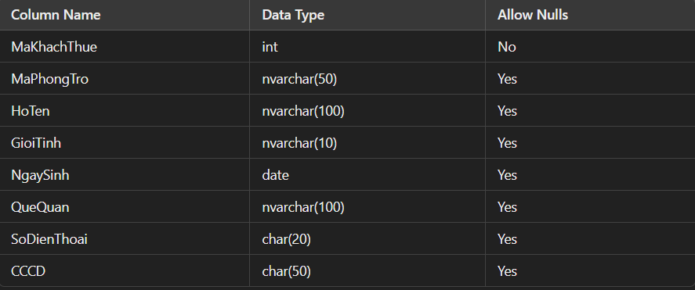
- Manage Tenant information table
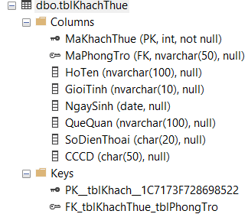

- Description: Store tenant information.

- MaKhachThue: The primary key that identifies the tenant.

- MaPhongTro: Foreign Key links to the tblPhongTro table, indicating which room the tenant belongs to.

- Other information such as: Full Name, Gender, Date of Birth, Hometown, Phone Number, CCCD (Citizen Identification Card).

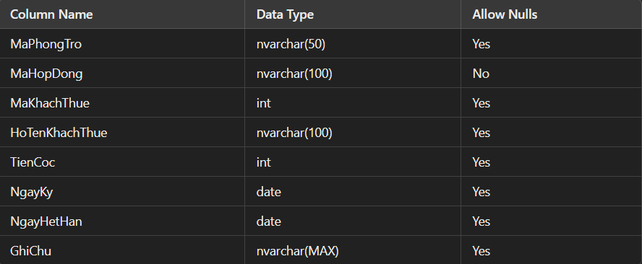
- Manage Contracts table
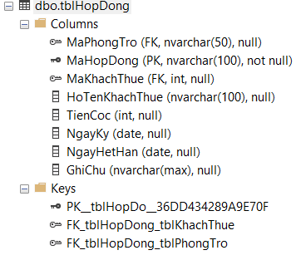

- Description: Save room rental contract information.

- MaHopDong: Primary Key identifying the contract.

- MaPhongTro: Foreign Key linking to tblPhongTro.

- MaKhachThue: Foreign Key linking to tblKhachThue.

- Other information such as: HoTenNgoiKy, TienCoc, NgayKy, NgayHetHan, GhiChu.

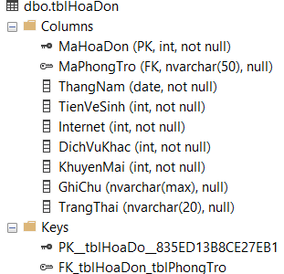
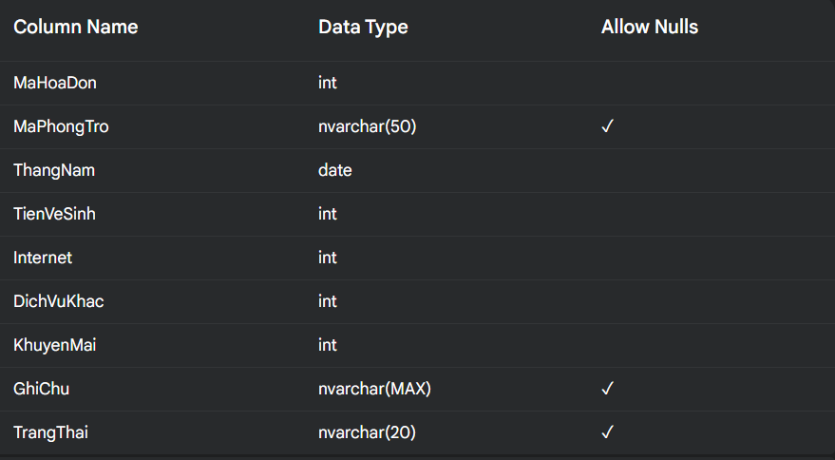
- Manage Invoices table

- Description: Save bill information for each room

- MaHoaDon: Primary Key identifying the invoice.

- MaPhongTro: Foreign Key linking to tblPhongTro.

- ThangNam: Month and year of the invoice.

- Other services such as: TienVeSinh, Internet, DichVuKhac, KhuyenMai, Note

- TrangThai: Payment status.

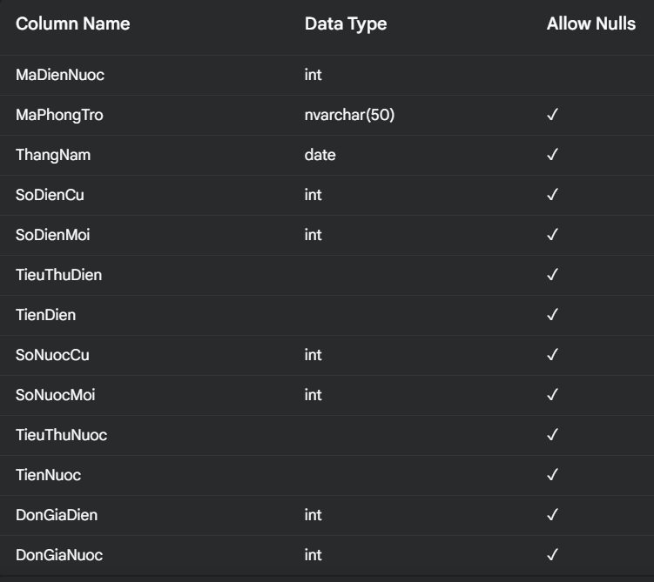
- Electricity and water table
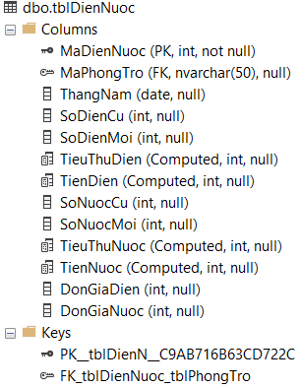

- Description: Store electricity and water information for each room

- MaDienNuoc: Primary Key identifying the electricity and water record.

- MaPhongTro: Foreign Key linking to tblPhongTro.

- ThangNam: Month and year of use.

- SoDienCu, SoDienMoi, TieuThuDien: Old and new electricity index and consumption.

- SoNuocCu, SoNuocMoi, TieuThuNuoc: Old and new water index and consumption.

- Other information: TienDien, TienNuoc, DonGiaDien, DonGiaNuoc: Electricity and water bill and unit price.

- Manage Invoices Details table
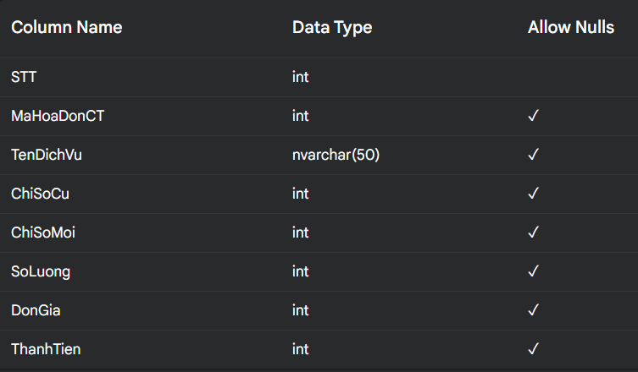

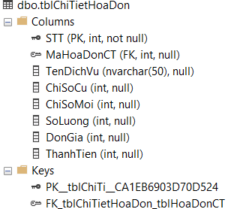

- Description: Save details of items in the invoice.

- STT: Primary Key identifies each item.

- MaHoaDonCT: Foreign Key links to tblHoaDon.

- TenDichVu: Service name.

- ChiSoCu, ChiSoMoi, SoLuong: Old and new index and consumption quantity.

- Other information: DonGia, ThanhTien: Unit price and total amount.

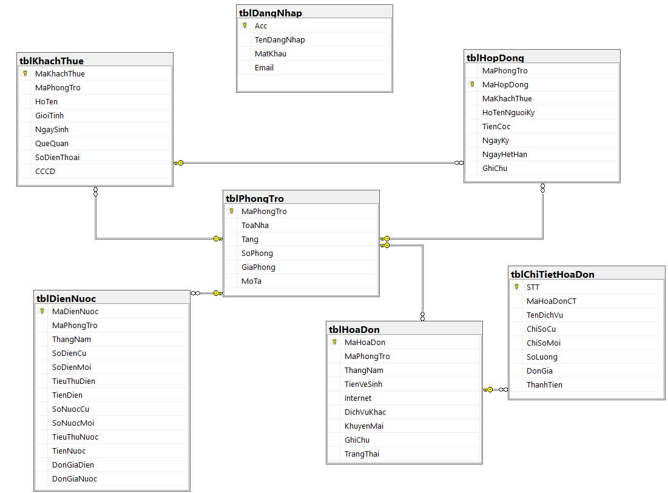
2.Entity Relationship Diagram

CHAPTER III: LIST OF IMAGES
- Login/Register
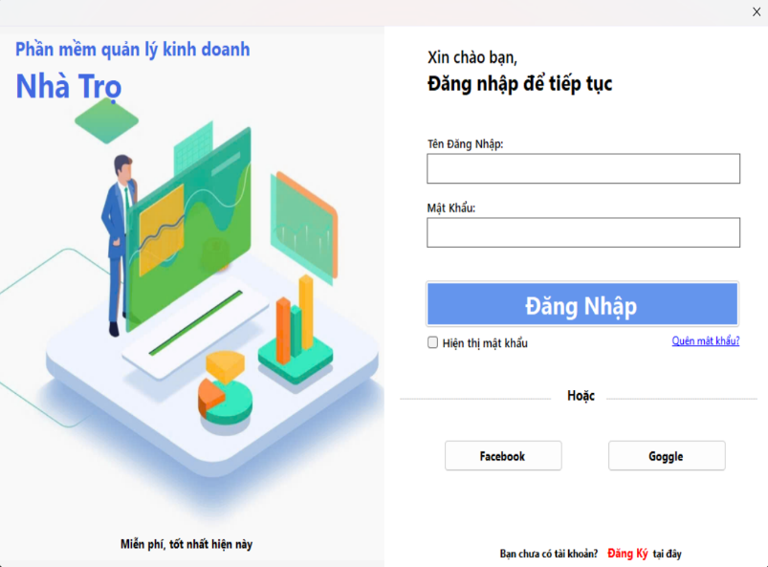
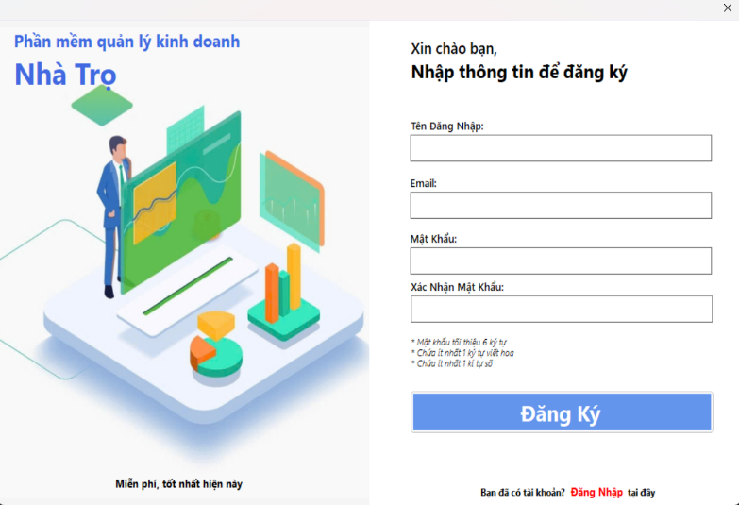

- Users must create an account to be able to log in to the program and the password when creating an account must have numbers and uppercase characters.

- After creating an account, the user needs to enter the correct username and password.
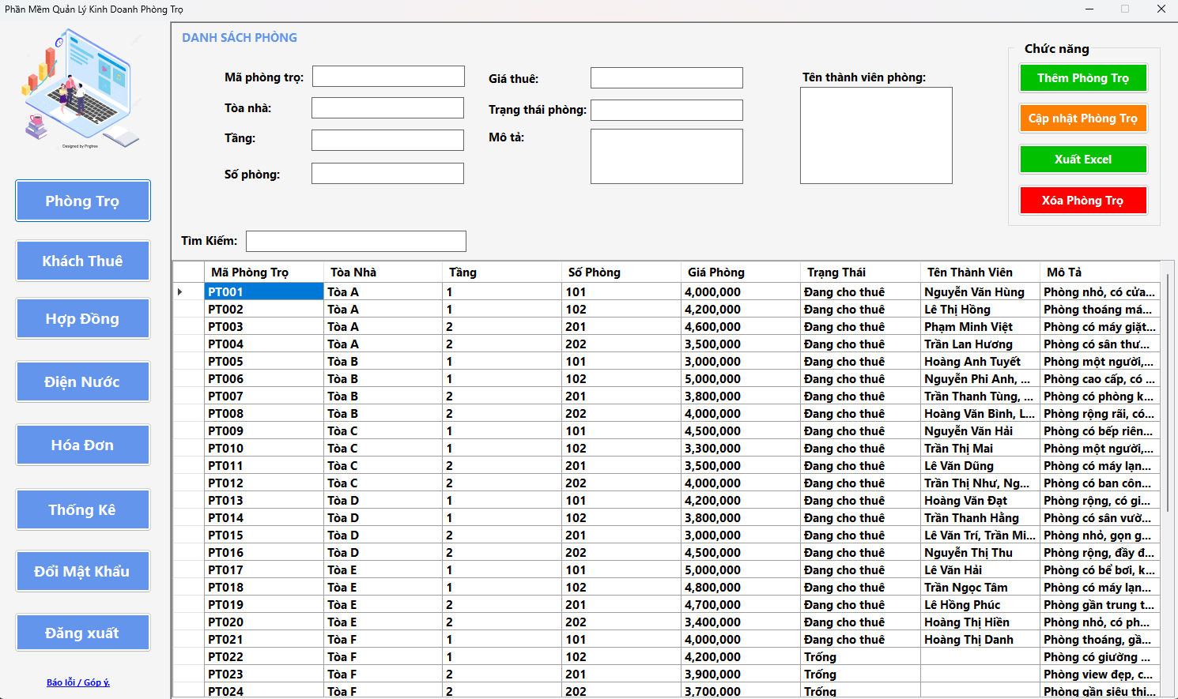
- Manage Rooms
- If the room status is occupied, it is currently rented, otherwise it is vacant. The room member box is easy to manage and see who is in the room to quickly find information.

- Room management can search by existing conditions

- Users can freely edit under the data section by clicking on edit and update the room. Users can click on any row of information about one of the rooms in the data table and can change any information to add a new room or can edit or delete at the selected data row.

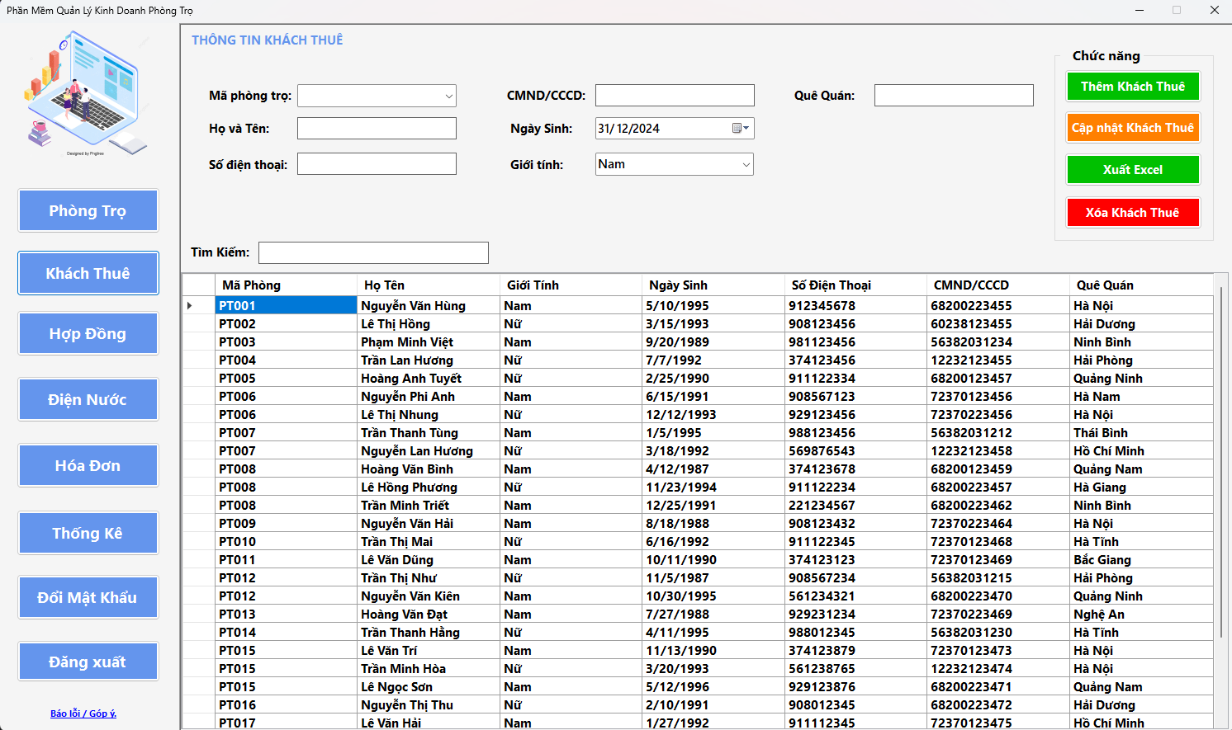
- Manage Tenant information.
- The tenant is linked to the room code to determine which room the tenant is staying in

- If the room is deleted, the tenant will also be deleted

- Phone number and ID card only allow them to enter numbers. Full names, hometown cannot contain special characters such as @ # ...

- Users can freely edit under the data section by clicking on edit and update the room. Users can click on any row of information about one of the rooms in the data table and can change any information to add a new room or can edit or delete at the selected data row
- Manage Contracts
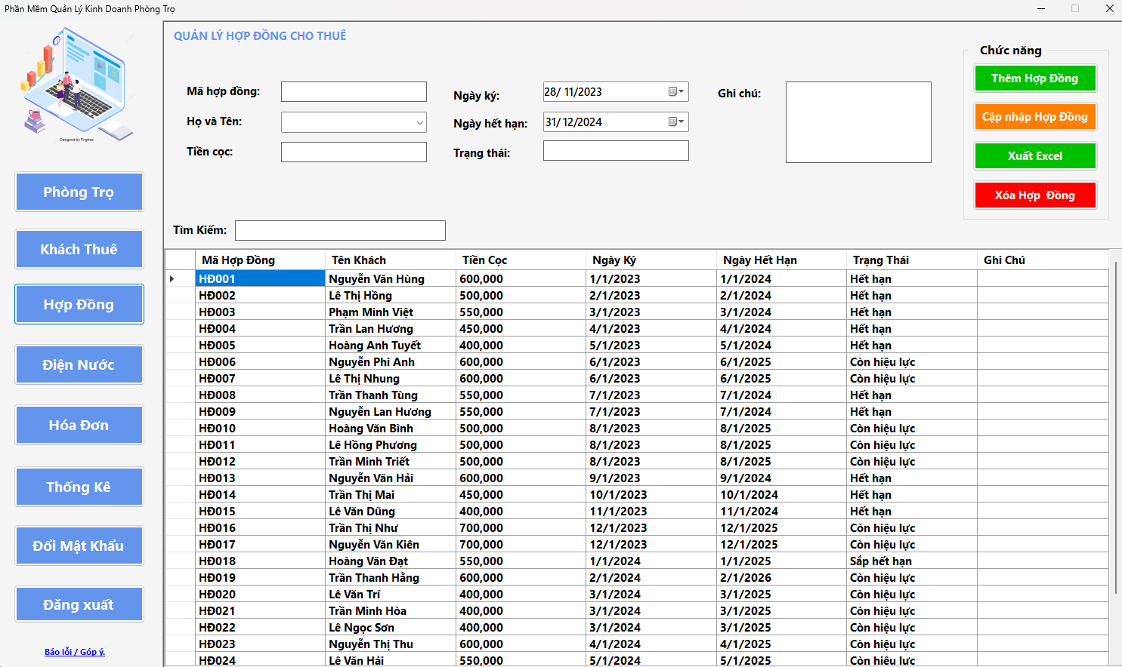

- Contract status is based on the expiration date compared to the actual time.

- The contract code will follow the tenant, the contract codes cannot be duplicated, the name on the contract must exist in the tenant management to be allowed to add or edit the contract, otherwise an error will be reported

- Deposit can only be entered in numbers

- If it is about 1 month, it is about to expire. If it is more, it is still valid. Compared to the actual time, if it is more, it is expired.

- Users can freely edit under the data section by clicking on edit and update the room. Users can click on any row of information about one of the rooms in the data table and can change any information to add a new room or can edit or delete at the selected data row.

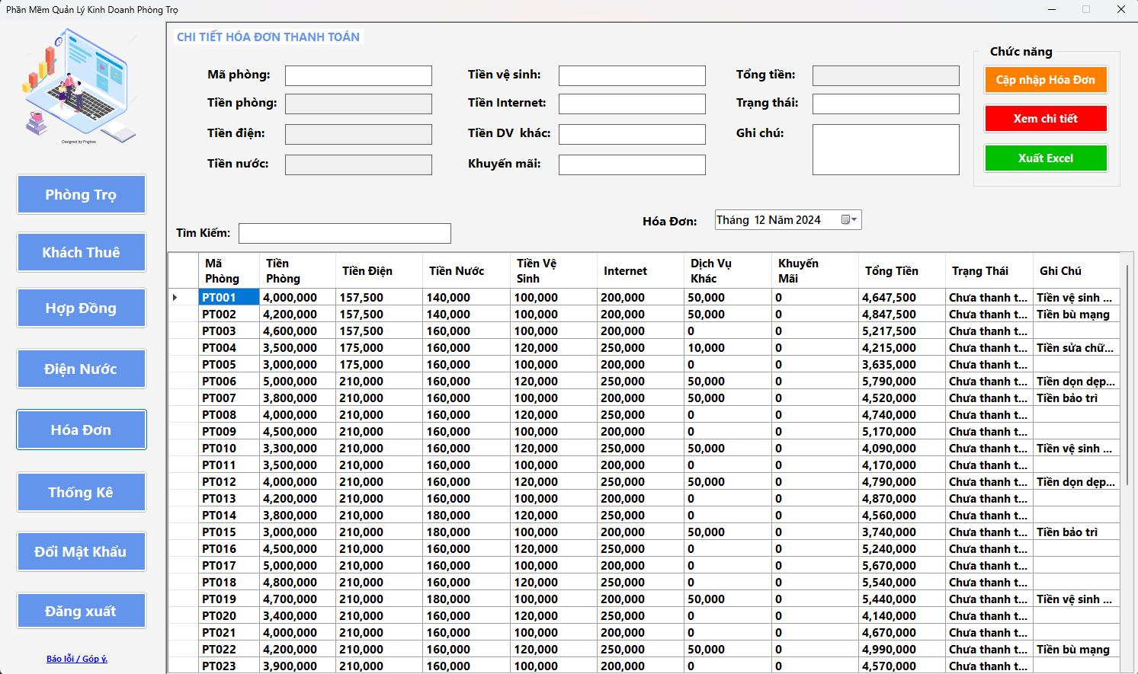
- Manage Invoices

- Cleaning fees and internet fees are inherited from the current month until user changes

- Bill calculation formula = Total of all except promotions

- When the invoice is transferred to a new month, the data table will automatically change the information to that month.

- Users can freely edit under the data section by clicking on edit and update the room. Users can click on any row of information about one of the rooms in the data table and can change any information to add a new room or can edit or delete at the selected data row.

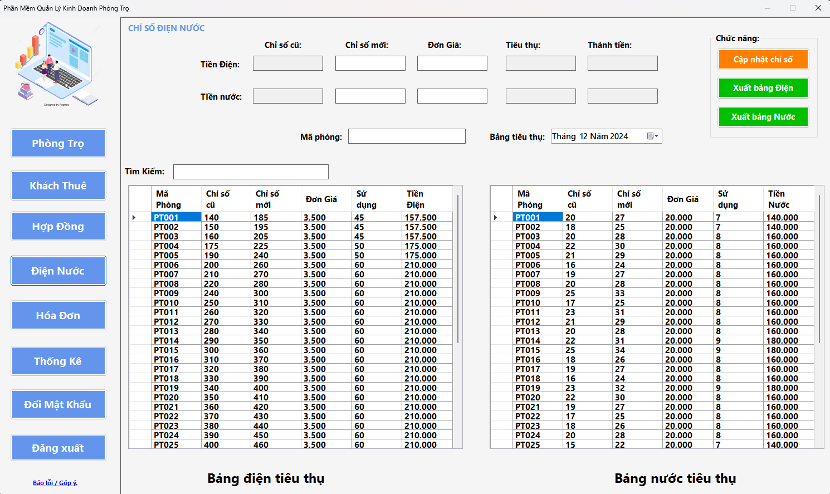
- Electricity and water management.

- The electricity index from the new index this month to the next month will be inherited to the old index, the unit price for the next month will be inherited from the current month now until the user changes it.

- Formula for calculating electricity and water bills = (new index - old index) * unit price

- Internet cleaning fee will be automatically updated next month compared to current month, each month of use just need to enter other services or promotions if any. The bill will be automatically calculated.

- Users can freely edit under the data section by clicking on edit and update the room. Users can click on any row of information about one of the rooms in the data table and can change any information to add a new room or can edit or delete at the selected data row.

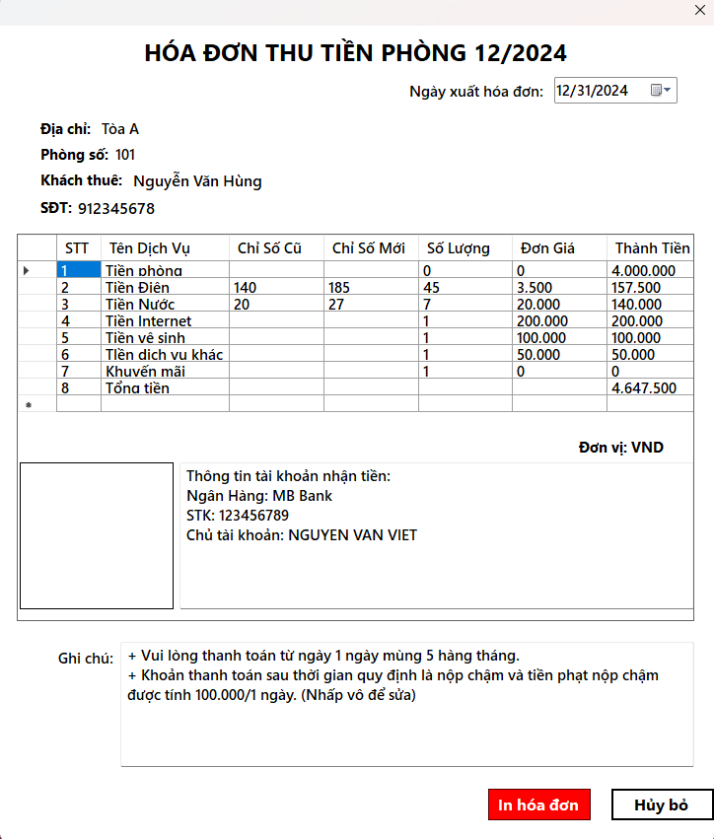
- Invoices Details

- The information in the detailed field is set for user input to change.

- The blank box next to the receiving account can be used to select a photo, the user can enter changes, and this photo is saved for the next invoices.
- Statistical
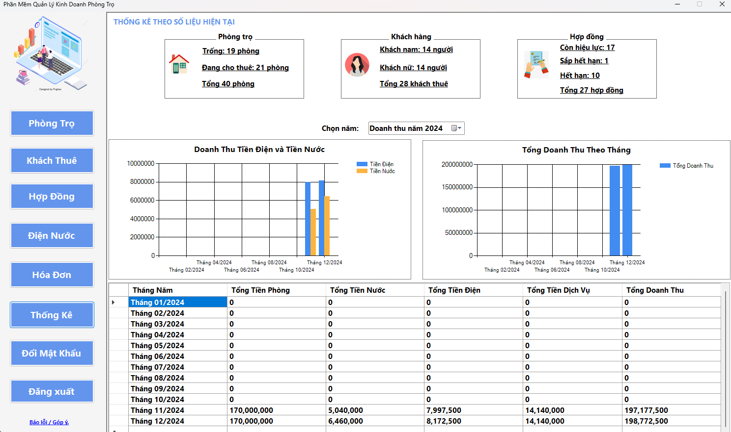
- The statistics will show the user:
- How many rooms are currently available in the room database and how many are currently rented and how many are not rented

- How many guests are in the guest database and how many are male and how many are female

- How many contracts are in the contract database and how many are active, expiring and expired.

- Electricity and water revenue:
- This chart shows the revenue from electricity and water over the months of 2024.

- Blue column: Represents revenue from electricity.

- Yellow column: Represents revenue from water.

- Purpose: Compare the revenue from these two sources each month, helping landlords grasp more details about the revenue from electricity and water.

- Total Revenue by Month
  - This chart shows total revenue from all sources (room, electricity, water, and other services) by month in 2024.

  - Purpose: Helps managers easily observe monthly revenue trends, detect months with unusually high or low revenue.

- Search function
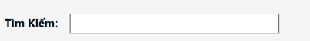

- The search function will be available in other functions including room management, tenant information management, contract management, bill management and electricity and water management.

- And each search function in other functions has different search conditions.

  - Tenant information management can search by available conditions except for birth date

  - Contract management can search by available conditions except for signing date and expiration date

  - Invoices management can only search by room code, status and notes

  - Electricity and water management can only search by room code

- Change Password
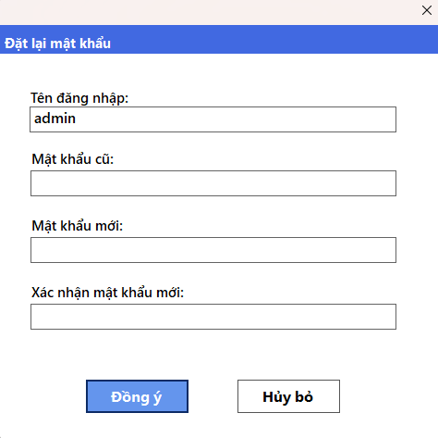

- Validate old password: Requiring the old password to be entered ensures that only the actual user (account owner) can change the password. This reduces the risk of unauthorized password changes.

- Confirm new password: Re-entering the new password to confirm helps avoid password entry errors, ensuring the new password is set correctly.

- Export Excel file
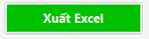
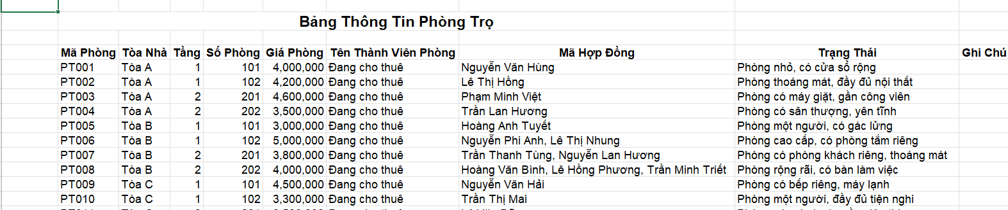
- This function allows users to export excel files of each corresponding function, and when exported, it will store the information of that function and show that information to the user.

- Suggestion Box
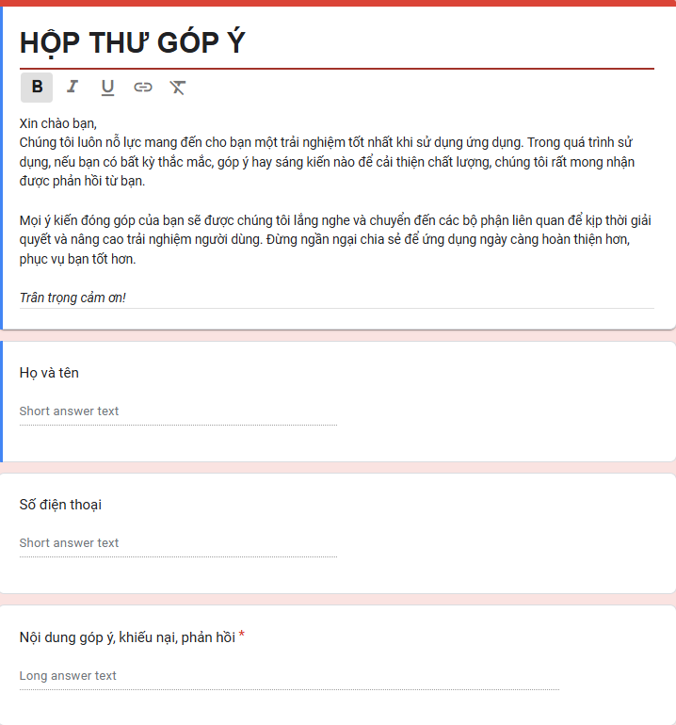
- This suggestion box will collect opinions and complaints about the application from users to help the app know the errors that may occur when users use it, and they will fix the errors to be able to perfect the application.

Chapter IV: UPCOMING FEATURES
- Login by Google and Facebook
- In the context of increasingly developing digitalization, applying technology to manage boarding houses not only helps save time but also improves operational efficiency. An important and useful feature that boarding house management applications can integrate in the future is the function of logging in with Google and Facebook.

- Why is this function needed:
  - Convenient for users: Users do not need to create a new account, just use their existing Google or Facebook account.

  - Higher security: Google and Facebook offer strong security protocols that help protect users' personal information.

  - Save development time: Integrating Google and Facebook APIs reduces the time it takes to build an account management system from scratch.

- Send invoices to tenants through email
- In the digital age, automating management processes saves time and increases operational efficiency. One useful feature that a hostel management application can integrate in the future is sending invoices to tenants via email.

- Why is this function needed:

  - Convenient for tenants: Tenants can receive invoices quickly, store them easily and retrieve them at any time.

  - Cost savings: Minimize paper printing and shipping costs.

  - Increase professionalism: Automating the invoice sending process helps improve the reputation and service quality of the boarding house.
- Conclusion

- We did this project from November 23, 2024, to January 4, 2025, a period that is not too long but not too short. After studying this desktop application course, we learned many things such as how to use the necessary tools to create an application, learn more necessary tasks to be able to deploy functions such as connecting to the database or formatting for each tool in visual studio.

- In addition, during the project implementation process, we also learned how to solve practical problems, from handling errors in the program to optimizing the performance of the application. These are skills that are not only useful for this subject but also necessary for future real-life projects. The project not only helps us improve our programming knowledge but also trains our logical thinking, teamwork skills and the ability to solve problems effectively.

- Although the project implementation time is not too long, this is truly a meaningful journey and brings many valuable lessons to us.

Finally, we would like to sincerely thank lecturer Hoang Van Hieu for supporting and giving us feedback so that we can complete this project. There may be mistakes in the work, but if there are, it will be an experience for us in the future so that we can complete it better in the future. And thank you for reading the report. Have a nice day.

